**Sudoku Solver (Backtracking 2)**

**Java**

Write a program to solve a Sudoku puzzle by filling the empty cells.

A sudoku solution must satisfy all of the following rules:

1. Each of the digits 1-9 must occur exactly once in each row.
2. Each of the digits 1-9 must occur exactly once in each column.
3. Each of the digits 1-9 must occur exactly once in each of the 9 3x3 sub-boxes of the grid.

The '.' character indicates empty cells.

**Sample Input**

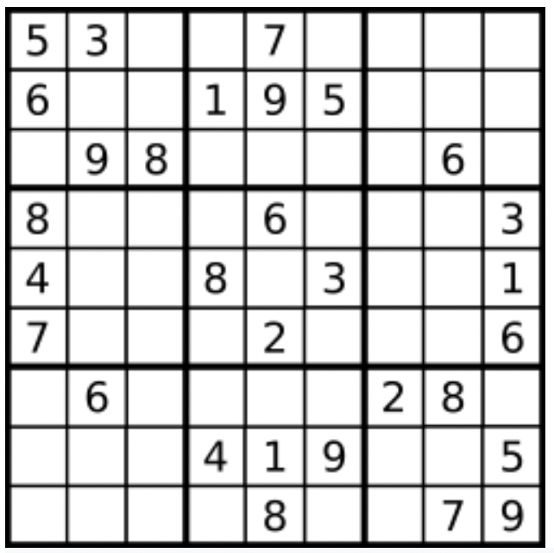

board = [["5","3",".",".","7",".",".",".","."],["6",".",".","1","9","5",".",".","."],[".","9","8",".",".",".",".","6","."],["8",".",".",".","6",".",".",".","3"],["4",".",".","8",".","3",".",".","1"],["7",".",".",".","2",".",".",".","6"],[".","6",".",".",".",".","2","8","."],[".",".",".","4","1","9",".",".","5"],[".",".",".",".","8",".",".","7","9"]]

**Sample Output**

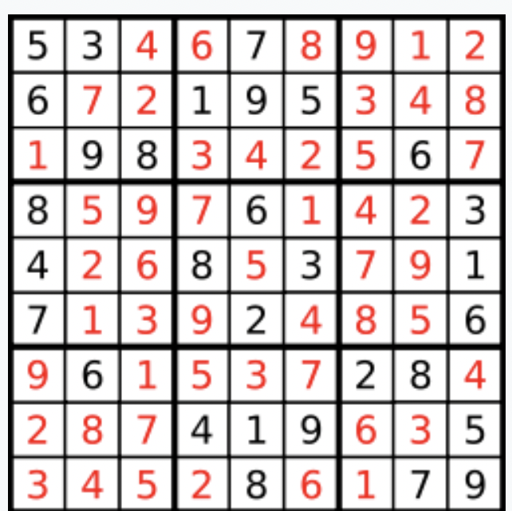

[["5","3","4","6","7","8","9","1","2"],["6","7","2","1","9","5","3","4","8"],["1","9","8","3","4","2","5","6","7"],["8","5","9","7","6","1","4","2","3"],["4","2","6","8","5","3","7","9","1"],["7","1","3","9","2","4","8","5","6"],["9","6","1","5","3","7","2","8","4"],["2","8","7","4","1","9","6","3","5"],["3","4","5","2","8","6","1","7","9"]]

**Code**

1. StartingRow = 3*(row/3) & StartingCol = 3*(col/3)
2. StartingRow = row - row%3 & StartingCol = col - col%3

**Code**

class Solution {

public boolean isSafe(char[][] board, int row, int col, int number) {

//column

for(int i=0; i<board.length; i++) {

if(board[i][col] == (char)(number+'0')) {

return false;

}

}

//row

for(int j=0; j<board.length; j++) {

if(board[row][j] == (char)(number+'0')) {

return false;

}

}

//grid

int sr = 3 * (row/3);

int sc = 3 * (col/3);

for(int i=sr; i<sr+3; i++) {

for(int j=sc; j<sc+3; j++) {

if(board[i][j] == (char)(number+'0')) {

return false;

}

}

}

return true;

}

public boolean helper(char[][] board, int row, int col) {

if(row == board.length) {

return true;

}

int nrow = 0;

int ncol = 0;

if(col == board.length-1) {

nrow = row + 1;

ncol = 0;

} else {

nrow = row;

ncol = col + 1;

}

if(board[row][col] != '.') {

if(helper(board, nrow, ncol)) {

return true;

}

} else {

//fill the place

for(int i=1; i<=9; i++) {

if(isSafe(board, row, col, i)) {

board[row][col] = (char)(i+'0');

if(helper(board, nrow, ncol))

return true;

else

board[row][col] = '.';

}

}

}

return false;

}

public void solveSudoku(char[][] board) {

helper(board, 0, 0);

}

}